Bilateral Diabetic Retinopathy on the DRS Plus
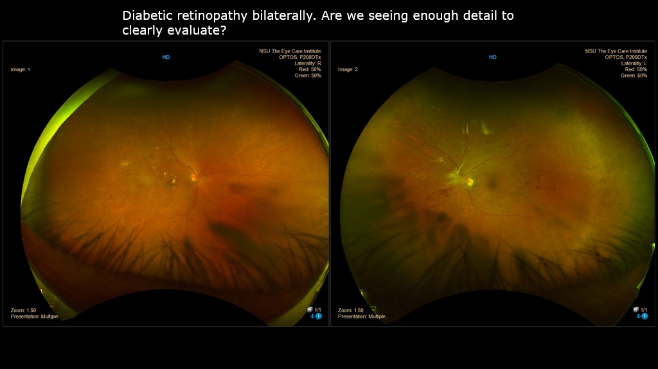
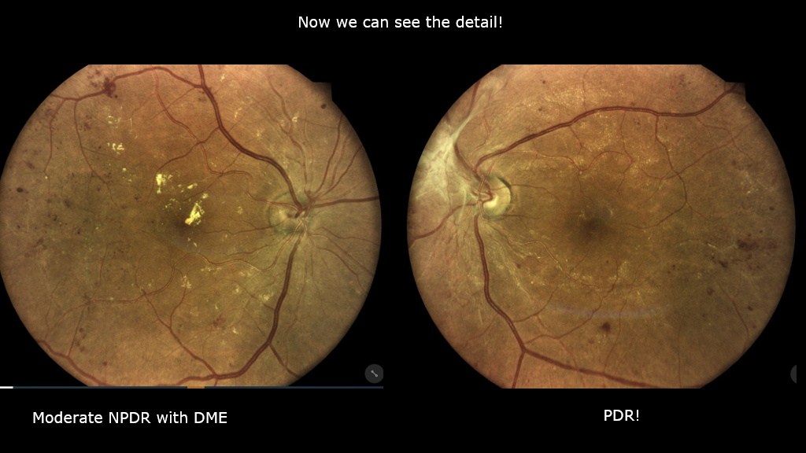
 Eidon UWF Images Courtesy of Julie Rodman OD, FAAO

